Chroma Meter Detail/Notes

**2015**

Optical Applications

Intersil

6/16/2015

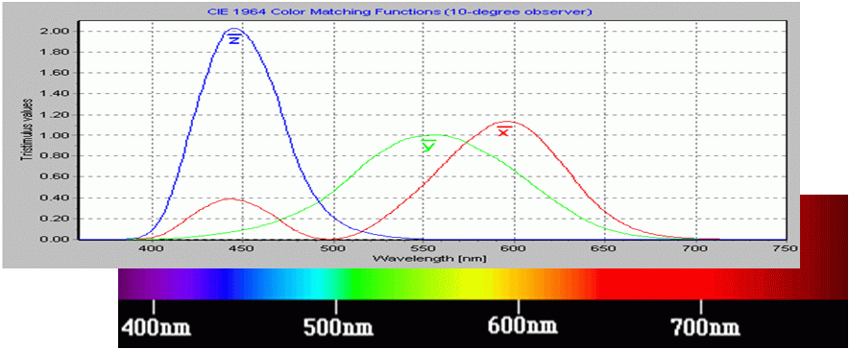

# ISL29125 Evaluation Board Calibration Procedure

## Connect ISL29125 evaluation board to the PC/Laptop via μUSB cable

## Launch "Chroma meter"

1. Open EEprom GUI by clicking on "CCM" on the left top corner **①**



1. Chroma Meter GUI and related EEprom GUI
2. Set I2C address to 0xA4 for Evaluation card as shown in 0.**②**
3. Click on "Read" to read out the calibration data from EEprom.**③**The latest EEprom calibration data version should be 5 **④** if not, import the calibration header text from “default.txt” **⑤** as shown in the rightmost panel under installation directory by pressing Read button.  
     
   “C:\Program Files\Intersil\RGB Chroma Meter\CCMfiles”  
     
   Note above directory may be changed depending on the installation directory of Chroma meter
4. Click on 'Run' button so that it changes to 'hold' before Calibration in excel.**⑥**

## Launch "simple.ALS.drv.xlsm"

Go to Tab “EVB CCT Cal”. Hit "Reset" button **①** to clear the historical calibration data including the calibration data section (green part) **②**, IR compensation and Measured XYZ values (yellow sections) **③**.



1. Calibration Spreadsheet

## Perform IR compensation calibration

1. IR compensation section

### Measure A luminance lux (EV value)

1. Turn on 3200K/8000 lux light source (Quartz Tungsten Halogen (QTH) lamps).
2. Place the color conversion filter (D30 to A) between the QTH light source and the Integrated sphere to generate the A illuminant (CCT~2800K)
3. Input the chroma meter reading of A illuminant light level (lux) value. **①**
4. Press the button “A0”. **②**

### Measure CWF luminance lux (EV value)

1. Turn on 3200K/8000 lux light source (Quartz Tungsten Halogen (QTH) lamps).
2. Place the color filter (D30 to CWF) between the light source and the integrated sphere to generate CWF illuminant (CCT ~4000K)
3. Input the chroma meter reading of CWF illuminant light level (lux) value. **③**
4. Press the button “CWF0”. **④** The IR compensation values can be found to the right side of CompSet. **⑤**

## Perform CCM calibration



1. XYZ calibration section

### Measure CWF illuminant tristimulus values (XYZ)

1. Turn on 3200K/8000 lux light source (Quartz Tungsten Halogen (QTH) lamps).
2. Place the color filter (D30 to CWF) between the light source and the integrating sphere to generate the CWF illuminant (CCT 4000K)
3. Input the chroma meter reading of XYZ values into the CWF Cells **①** in tab “EVB CCT Cal” and Press button “CWF”. **②**

### Measure D65 illuminant tristimulus values (XYZ)

1. Turn on 3200K/8000 lux light source (Quartz Tungsten Halogen (QTH) lamps).
2. Place the color filter (D30 to D65) between the light source and the integrating sphere to generate the CWF illuminant (CCT 6500K)
3. Input the chrome meter reading of XYZ values into the D65 Cells **③** in tab “EVB CCT Cal and Press button “D65”. **④**

### Measure A illuminant tristimulus values (XYZ)

1. Turn on 3200K/8000 lux light source (Quartz Tungsten Halogen (QTH) lamps).
2. Place the color filter (D30 to A) between the light source and the integrating sphere to generate the CWF illuminant (CCT~2800K)
3. Input the chrome meter reading of XYZ values into the A Cells **⑤** in tab “EVB CCT Cal” and Press button “A”. **⑥**

## Copy the generated CCM calibration value, CardGain, CCM and Range from green cells **①** and paste it into Chroma meter EEprom data region **②** and press “Write” button in the upper left corner. **③**



1. Final Calibration Write into EEprom

# Measuring IR/Clear

The ISL29125 has the capability of indirectly measuring the near infrared (NIR) content within the bandwidth of silicon photo diodes, roughly from 0.7 to 1.1 μm wavelengths. This section will detail how this measurement technique can be performed.

## Theory of Operation

The Green channel of the ISL29125 RGB sensor differs from the Red and Blue channel in that the design has features which help it perform the Lux / Y measurement independent from the other channels over a wider range of glass spectra (namely IR pass glass used for proximity sensing devices). The Red and Blue channels consist of color coated photo diodes combined with a short pass dielectric filter used to reduce IR energy. The Green channel combines a photo diode, a dielectric band-bass filter and an adjustable IR compensation (see Figure 6). The IR compensation subtracts a variable amount energy detected by an uncoated diode from that of the filtered diode. Since the response of a silicon photo diode is higher in the IR region than in the visible region then the majority of the power of a broadband (black body) source measured is in the infrared region. We can derive the “IR” detected by applying information we have measured with the system we are calibrating/characterizing as discussed in §1.4 to subtract the visible component from the uncoated diode.

1. ISL29125 Diode/Compensation Architecture

The compensated Green spectral response is designed to closely match the response of the Y̅ CMF (Color Matching Function) curve.

1. Detected Power = ∫ ( Spectral Response x Input Spectrum )



## Algorithm

The comparison of two measurements of the same power light source at different compensation settings is enough to measure the %/power (relative to visible lighting) in the IR region between visible & the limit of the silicon photodiode (~1.1μm). The higher the compensation setting the lower the detected power is measured by the RGB. The relationship is linear and inversely proportional. The higher the IR content is in the source the steeper the slope is for a given change in the compensation value. Following the definitions in **Error! Reference source not found.**:

1. %IR Calculation



1. ΔTotal: is the total change in the detected value between the two compensation settings
2. ΔIR: is equal to the total change minus the change do to visible lighting alone.
3. VisibleAdj: is what % of the measured value has changed from the visible content. This value should be near 0.15% for the system measured in §1.4.
4. ΔVisible: is the amount of the change in the value do to visible lighting.
5. ΔIR: solved in terms of the values measured values combined with calibration/characterization values of the system.

Note that for a given light source ΔIR/ΔTotal should remain constant. If a significant color temperature change has not been detected then the IR content of the light will remain proportional to the visible content. Since this is true then there is no reason to repeatedly toggle the compensation setting to measure the IR unless a significant color temperature change (i.e. > 20%/value) has be detected.

## Pseudo code

Example code is shown in Figure 8.

1. Pseudo code

initialization:

// values defined in §1.4

compSet = X

if |X| > 0 then

Δcomp = 0

else

Δcomp = 10

end if

visibleAdjust = 0.15%

return

mainLoop:

:

measureRGB

lastGreen = green

:

:

if |ΔCCT| > 20% then

measureIRratio

else

irValue = irRatio * green

end if

return

measureIRratio:

setToGreenOnly

setCompToDeltaComp

waitUntilConversionDone

getGreenValue

if compSet > 0 then // Δcomp is = 0 (higher power detected)

ΔIR = green – lastGreen * (1 + visibleAdjust)

else

ΔIR = lastGreen – green * (1 + visibleAdjust)

end if

irRatio = ΔIR/lastGreen

return

## Example

The

1. Example Calibration Values

Positive Compensation



Negative Compensation



# Addenda

## GUI Widgets

1. Main Panel Widgets (xy view)



1. Main Panel Widgets (Bars view)



1. EEprom Widgets



1. sRGB Widgets

